ATTACKS ON THE OSI MODEL: CASE STUDIES AND REPORT

**INTRODUCTION**

The OSI (Open Systems Interconnection) model is a conceptual framework that provides a structured approach to understanding and implementing network protocols. It consists of seven layers, each serving a specific purpose in the communication process. This report provides an introduction to the OSI model and offers a detailed analysis of common attacks that can occur at each layer. By understanding the vulnerabilities at each layer, network administrators can better protect their systems and mitigate potential security risks.

**Common Security Attacks in Each Layer** of the OSI Model

Attacks targeting the OSI model can exploit vulnerabilities at each layer, aiming to compromise network infrastructure, steal data, or disrupt communication. Here is an in-depth analysis of some common attack types and techniques at each layer of the OSI model:

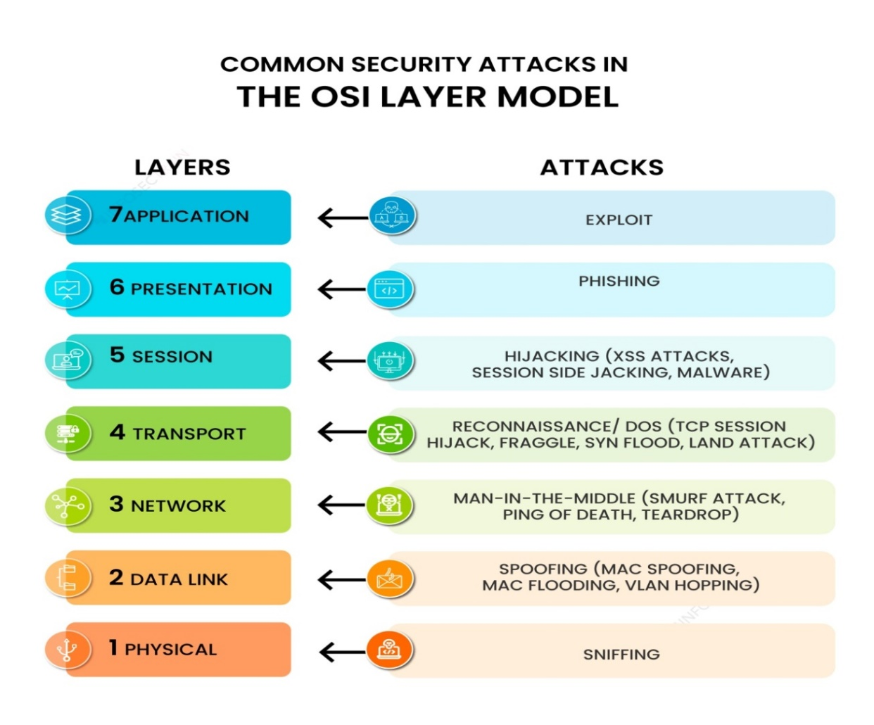

Application layer

The application layer is the closest to users in the OSI layer model and establishes the communication between the user and applications with which they interact individually. The common security attack on this layer is an exploit.

Attack

Cross-Site Scripting (XSS): Injecting malicious scripts into web applications to steal data or perform unauthorized actions on behalf of the user.

SQL Injection: Exploiting vulnerabilities in web application databases to manipulate or extract sensitive data.

Distributed Denial of Service (DDoS): Coordinating a large number of compromised systems to flood target applications or networks with excessive traffic, rendering them inaccessible.

These attack vectors and techniques highlight the need for comprehensive security measures across all layers of the OSI model. Protecting against these attacks involves implementing robust network security protocols, regularly updating software and firmware, employing intrusion detection/prevention systems, and educating users about security best practices.

**Mitigation**: Secure coding practice, Input validation, Web application firewall

Presentation layer

The presentation layer specifies the two devices’ encoding, encryption, and compression methods for proper communication. Anything sent from the application layer is received by the presentation layer, which is transformed into a format suitable for transmission via the session layer. Phishing is one of the common security attacks carried out by attackers in this layer.

Attack

Code Injection: Inserting malicious code into data streams to exploit vulnerabilities in applications or compromise systems.

Format String Attacks: Exploiting vulnerabilities related to format string input validation to execute arbitrary code or crash systems.

Malware Payloads: Embedding malware within data streams or file formats to infect systems or steal information.

**Mitigation**: Use of strong encryption algorithms and proper key management practice, Input validation, parameterized queries, WAF

**Session layer**

The session layer establishes communication channels between devices, known as sessions. It starts sessions, keeps them open and effective while data is transferred, and closes them after communication is completed. Hijacking is one of the common security attacks that occurs in this layer.

**Attack**

Session Hijacking: Unauthorized interception and takeover of an existing session, allowing attackers to impersonate the legitimate user.

Replay Attacks: Capturing and retransmitting legitimate session data to gain unauthorized access or perform malicious actions.

**Active session hijacking**: In this, the attacker takes control of an active user session on a network and intercepts and alters network traffic in real time.

**Passive session hijacking**: In this, attackers monitor network traffic and wait for users to log into a website; at that point, the attackers take over the session

**Mitigation**: Encryption, Use of Secure Protocols, session management controls

Transport layer

The transport layer performs flow control, transmitting data at a frequency corresponding to the receiving device’s connection speed and error control, determining whether data was received wrongly and requesting it if necessary. The most common security attack that is carried out in this layer is reconnaissance.

Attack

SYN Flood: Overwhelming a target system with a flood of TCP SYN requests, exhausting system resources and rendering it unresponsive.

TCP/IP Hijacking: Intercepting and manipulating TCP sessions to gain unauthorized access or tamper with data.

UDP Flood: Flooding a target system with a high volume of UDP (User Datagram Protocol) packets, leading to denial of service.

**Mitigation**: Intrusion Prevention system, Load balancer, Transport Layer Security (TLS)

Network layer

There are two primary jobs that the network layer does. One breaks up the segments into network packets and then puts the packets back together at the other end. The other is sending packets through a physical network by finding the best route. One of the most common security attacks in this layer is a man-in-the-middle attack.

* Address Resolution Protocol (ARP) spoofing
* DHCP spoofing
* MAC flooding

**Mitigation**: Access control lists (ACL’S), Firewall, Disabling ICMP functionality

Data link layer

The data link layer establishes and terminates communication between two technically connected network nodes. It divides packets into frames and transmits them from source to destination. In this layer, attackers use spoofing attacks to target the network system.

Attack

**MAC Spoofing:** Attackers forge or manipulate MAC addresses to gain unauthorized access to a network or launch impersonation attacks.

**VLAN Hopping:** Exploiting misconfigurations or weaknesses in VLAN implementations to bypass network segmentation and gain unauthorized access to sensitive information.

**ARP Spoofing/Poisoning:** Manipulating the ARP protocol to associate a legitimate IP address with a different MAC address, allowing for network eavesdropping or Man-in-the-Middle attacks.

**Mitigation**: MAC address filtering and dynamic ARP inspection

**Physical layer**

The physical layer is responsible for adequately connecting network nodes via wired or wireless means. Sniffing is the most common security attack used by attackers to target the data link layer.

**Attack**

**Cable Tapping:**  Attackers physically tap into network cables to intercept and capture data transmissions.

**Hardware Interference:** Physical tampering with network devices, such as inserting rogue devices or modifying hardware components, to gain unauthorized access or disrupt network operations.

**Mitigation**: use of secure encryption technologies, such as VPN

**CASE STUDIES**

**Case Study 1 : Mirai Botnet (Data Link and Network Layer Attacks)**

**Overview**: In 2016, the Mirai botnet launched large-scale Distributed Denial of Service (DDoS) attacks targeting various websites and Internet infrastructure.

**Attack Details**: The Mirai botnet exploited vulnerable IoT devices, such as routers, IP cameras, and digital video recorders, by using default or weak credentials. Once infected, these devices became part of the botnet and were controlled by the attackers to launch DDoS attacks.

**Impact and Consequences:**

Service Disruption: The Mirai botnet's DDoS attacks caused widespread service disruptions, including temporary or prolonged unavailability of popular websites and online services.

Infrastructure Strain: The attacks overwhelmed network infrastructure, causing congestion and impacting the availability and performance of internet connectivity.

IoT Device Security Concerns: The attack highlighted the vulnerabilities of IoT devices and the potential for massive botnet-driven attacks, raising concerns about the security of these devices.

**Countermeasures:**

Stronger IoT Device Security: Manufacturers and users must improve security measures for IoT devices, including implementing strong default credentials, regular firmware updates, and built-in security mechanisms.

1. Network Traffic Monitoring: Employing network traffic monitoring systems can help identify and mitigate abnormal traffic patterns associated with DDoS attacks.
2. Botnet Mitigation: Collaborative efforts between security organizations and ISPs are essential to identify and neutralize botnets. Employing techniques like sinkholing and blackholing can disrupt botnet communication and block malicious traffic.

These case studies demonstrate the critical importance of implementing robust security measures at various layers of the OSI model. They highlight the need for continuous vulnerability assessment, proactive threat detection, proper access controls, and user education to prevent and mitigate attacks across the network infrastructure.

**Case Study 1: Stuxnet Attack on Industrial Control Systems**

**Overview**:

The Stuxnet worm is one of the most infamous cyberattacks in history, targeting industrial control systems (ICS) and specifically aiming at Iran's nuclear facilities. The attack, discovered in 2010, exploited vulnerabilities across multiple layers of the OSI model.

**Impact and Consequences:**

1. Physical Damage: Stuxnet targeted programmable logic controllers (PLCs) used in centrifuges for uranium enrichment. By manipulating the ICS, the attackers were able to cause the centrifuges to spin at incorrect speeds, resulting in physical damage and reducing their operational efficiency.

2. National Security Implications: The Stuxnet attack was a state-sponsored attack aimed at sabotaging Iran's nuclear program. It demonstrated the potential for cyberattacks to disrupt critical infrastructure and impact national security on a global scale.

3. Escalation of Cyber Warfare: Stuxnet represented a significant escalation in cyber warfare tactics, showcasing the capability to cause physical damage through targeted attacks on industrial systems. This attack set a precedent for future attacks on critical infrastructure worldwide.

**Countermeasures**:

1. Patching and Updates: The vulnerabilities exploited by Stuxnet were patched after the attack was discovered. Regular updates and security patches are crucial to address known vulnerabilities and protect against similar attacks.

2. Network Segmentation: Implementing network segmentation between corporate networks and ICS can help isolate critical infrastructure from external threats. By limiting access points, it becomes harder for attackers to move laterally across the network and reach sensitive systems.

3. Enhanced Security Awareness and Training: Organizations need to educate employees about the risks of social engineering and phishing attacks, which are often used as entry points for sophisticated attacks like Stuxnet. Security awareness programs can help employees identify and report suspicious activities.